Westside Sacramento IRWMP Small Grant Program Guidelines 2026-27
The Westside Sacramento Integrated Regional Water Management (IRWM) Coordinating Committee has developed a small grant program to help achieve the vision of the Westside IRWM Plan (IRWMP). The Small Grant Program will disburse funds to projects or programs that align with the IRWMP's goals and objectives. No more than $80,000 of Westside IRWM Coordinating Committee (CC) funds will be committed to this program in 2026-27, with awards ranging from $1,000 to $20,000 per project. There are no match requirements; however, points will be awarded to projects and programs that demonstrate a local match. When appropriate, grantees will develop and display a sign at the project site indicating funding was provided by the Westside Sacramento IRWM CC Small Grant Program.

Members of the Coordinating Committee or their Alternates (one representative per member agency) will review and rank Small Grant applications. CC members or Alternates may not score their own agency’s projects. A member agency that submitted a project may not vote on its own project.

Funding Priorities
Eligible projects are those consistent with WS IRWM Plan goals and objectives or a subcomponent of an existing project in the Westside IRWM Plan. Prioritization of funding will not be limited to High Urgency and High Importance projects. This Small Grant program is intended to forward the progress of any of the Plan Goals and Objectives. See Plan Sections 6-3 and 6-4.

Submission Timeline
Proposals will be accepted starting August 1, 2026, and will be due by October 7, 2026. Projects will be reviewed and ranked individually by CC members or alternates. The total score for each project will be totaled and averaged to produce a prioritized list. The prioritized projects will be reviewed by the CC, with the final ranking adjusted to ensure fair distribution across counties and watersheds. Final project selection and approval will be decided at the November 4th, 2026 regular meeting.

Ranking Criteria
Priority Area | Available Points
Meets/contributes to Westside Sac IRWMP Goals | 20
Meets/contributes to Westside Sac IRWMP Objectives | 20
Benefits or is a key preliminary step toward benefiting multiple entities | 10
Benefits disadvantaged communities (as defined by: Climate Bond (Prop 4), see page 4) | 5
Benefits Tribal communities (state or federally recognized) | 7.5
Provides regional benefits or is a key preliminary step toward the provision of regional benefits | 10
Responds to climate change – either through adaptation or mitigation | 10
Secured matching funds | 5
Supports three or more Westside goals and/or objectives | 10
Grassroots organization – less than 7 staff or volunteer | 2.5

Invoicing and Reporting
- Cover letter to be included with each quarterly invoice briefly reporting activities during the last quarter (example Report and Invoice to be provided).
- Cover letter/reports to be addressed to the IRWMP CC and submitted to the Chair for review and approval and to Solano County Water Agency, which is the current fiscal agent for the CC.
- Final Report to be included with final project invoice, plus any products developed through the grant, as well as high-resolution photos documenting the project (i.e., educational materials, outreach materials).
- Unexpended funds may be carried over no more than 1 year.

Westside Sac IRWMP 1-Year, Small Grant Program
Project Timeline and Expectations
Fiscal Year 2026-27

August 1, 2026 | - Call for Small Grant Program Requests for FY2026-27
October 7, 2026 | - Small Grant Program Requests due, preliminary review and ranking by Coordinating Committee members or Alternates
November 4, 2026 | - Projects selected and approved for funding at Regular meeting of the Coordinating Committee
December 2026 | - Detailed Scope of Work, Schedule and Budget submitted for selected projects;  - Contracts completed; Fiscal Agent determined by CC annually  - Work begins on the contract completion date;  - Quarterly invoicing begins, including cover letter with summary of activities.
December 2026 – November 2027 | - Oral reports/updates to Coordinating Committee at Regular meetings may be requested.
December 31, 2027 | - Deadline for project completion (flexible)  - Final reports and invoices due January 15, 2028

Westside Sac IRWM Small Grant Program
Fund Request - Fiscal Year 2026-2027
Due on or before October 7, 2026
Requests will be discussed and selected at the November 4, 2026 regular CC meeting.
Maximum 2 pages; Email completed form to: reza@yolorcd.org

Project Title: Click or tap here to enter text.

Project Budget (requested + match = Total): $ + $ = $

Date Submitted (month/day/year): Click or tap here to enter text.

Project Sponsor: Click or tap here to enter text.

Project Description: Click or tap here to enter text.

Project Status (check all appropriate boxes)
☐ Concept/development stage
☐ Planning/feasibility
☐ Permitting
☐ Design
☐ Construction
☐ Operation

Project Benefits:
Explain how this project advances the Goals and/or objectives of the Westside Sac IRWM Plan (refer to specific IRWM Plan goals or objectives).
Click or tap here to enter text.

Agencies/Entities Involved:
Lead Agency (Name): Click or tap here to enter text.

Other Agencies/Entities (Name): Click or tap here to enter text.

Consultants Involved (Names): Click or tap here to enter text.

Project Schedule (month/day/year): Beginning Date: Ending Date:

Climate Bond Disadvantaged and Severely Disadvantaged Communities

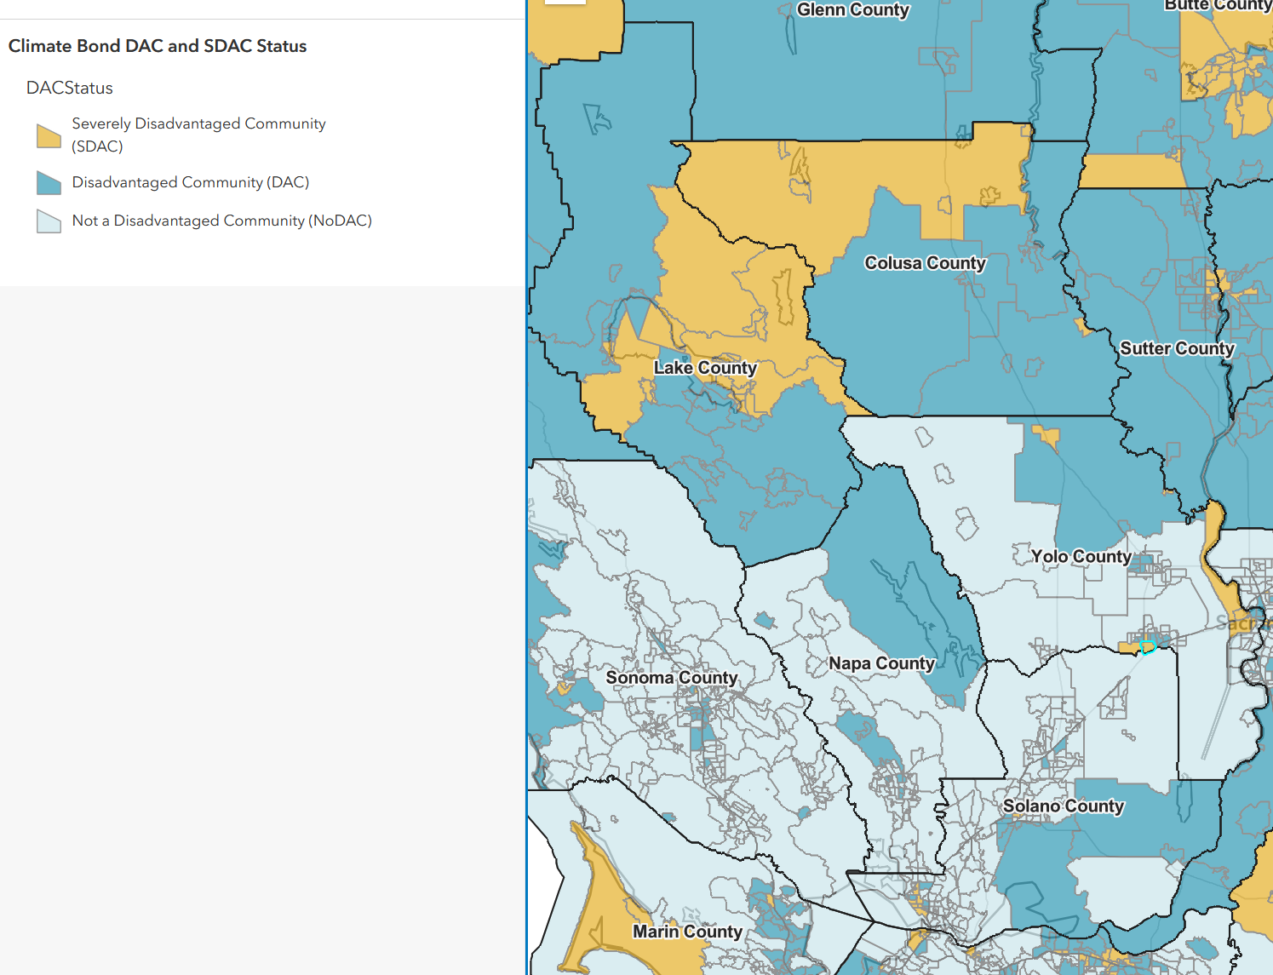

Scoring Criteria 2026 WS IRWM Small Grants
Request $1K - $20K? If no, ineligible
In Westside Sac IRWM region? If no, ineligible
Meets/ contributes to Westside Sac IRWMP Goals
(0 - 20)
CC representative expert assessment
Meets/ contributes to Westside Sac IRWMP Objectives
(0 - 20)
CC representative expert assessment
Benefits or is a key preliminary step toward benefitting multiple entities
(0 - 10)
CC representative expert assessment
Provides regional benefits or is a key preliminary step towards provision of regional benefits (0 - 10)
CC representative expert assessment
Responds to climate change through adaptation or mitigation
(0 - 10)
CC representative expert assessment
Secured Matching Funds
(0 - 5)
CC representative expert assessment
Benefits disadvantaged communities (as defined by CARB)
(0 - no; 2.5 - Disadvantaged; 5 - Severely Disadvantaged)
Benefits Tribal communities (state or federally recognized) (no - 0; yes - 7.5)
Supports 3 or more Westside goals and/or objectives (0, 6 - 10) (2 points per goal or objective, max 10 points)
Grassroots organization - less than 7 staff or volunteer (0 - 2.5) (0 - no; 2.5 - yes)
Total possible: 100

